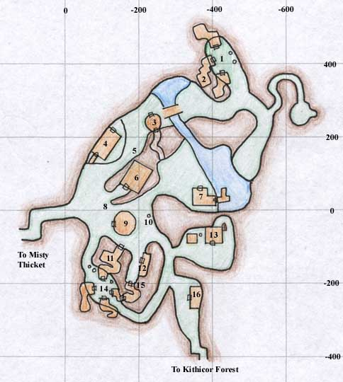

1. Pottery Wheel and Kiln

2. Nyla Gubbin's House

3. Merchants selling Bags and Fishing Supplies

4. Weary Foot Rest - Inn

5. Vale Forge

6. Town Hall and Leatherfoot Hall - Bank, Warrior Guild, Merchants selling Various Weapons

7. Merchants selling Food and other Goods, Fishing Supplies

8. Priest of Discord

9. Fool's Gold - Rogue Guild, Merchants selling Alcohol, Brew Barrel

10. Merchant selling Cloth Armor, Brew Barrel, and Loom

11. Merchants selling Potions and Crystals

12. Merchant selling Leather Armor and Patterns outside, Small Chain Armor and Small Chain Armor Patterns

13. Druid Guild with Merchants selling Ore, Veggies, Druid Weapons, and Druid and Ranger Spells, Forge and Oven outside

14. Pottery Wheel and Oven, Fletching and Bowyery Equipment, Weapon Molds

15. Merchant selling Potions and Crystals

16. Cleric and Paladin Guilds with Merchants selling Blunt Weapons and Cleric and Paladin Spells

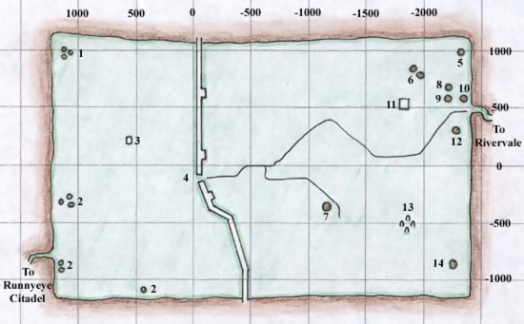

[Misty Thicket](https://wiki.project1999.com/Misty_Thicket)

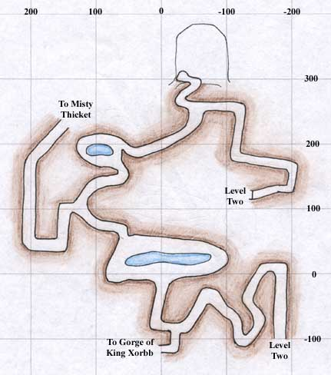

Level One

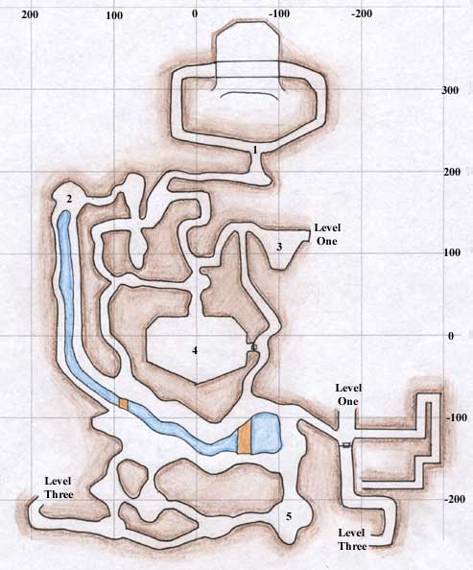

Level Two